**Requirement Gathering and Analysis Phase**

**Data Flow Diagram & User Stories**

|  |  |
| --- | --- |
| Date | 12 July 2024 |
| Team ID | SWTID1720068764 |
| Project Name | Book-Store |
| Maximum Marks | 3 Marks |

**Data Flow Diagrams:**

A Data Flow Diagram (DFD) is a traditional visual representation of the information flows within a system. A neat and clear DFD can depict the right amount of the system requirement graphically. It shows how data enters and leaves the system, what changes the information, and where data is stored.

Example: DFD Level 0 (Industry Standard)

**Example:** [**(Simplified)**](https://developer.ibm.com/patterns/visualize-unstructured-text/)

](https://developer.ibm.com/patterns/visualize-unstructured-text/) 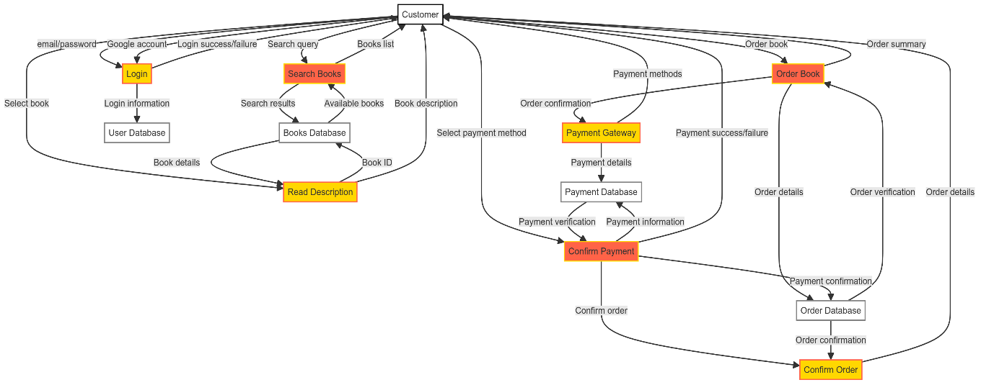

**User Stories**

Use the below template to list all the user stories for the product.

| **User Type** | **Functional Requirement (Epic)** | **User Story Number** | **User Story / Task** | **Acceptance criteria** | **Priority** | **Release** |
| --- | --- | --- | --- | --- | --- | --- |
| Customer (Mobile user) | Registration | USN-1 | As a user, I can register for the application by entering my email and confirming my password. | I can access my account/dashboard | High | Sprint-1 |
|  |  | USN-2 | As a user, I will receive a confirmation email once I have registered for the application | I can receive a confirmation email & click confirm | High | Sprint-1 |
|  |  | USN-3 | As a user, I can register for the application through Facebook | I can register & access the dashboard with Facebook Login | Low | Sprint-2 |
|  |  | USN-4 | As a user, I can register for the application through Gmail |  | Medium | Sprint-1 |
|  | Login | USN-5 | As a user, I can log into the application by entering my email & password |  | High | Sprint-1 |
|  | Dashboard | USN -6 | Implement a user dashboard displaying personalized recommendations and user profile information. | I can analyze my activity history here | Medium | Sprint-1 |
|  | Payment | USN-7 | As a user, I can securely enter payment details and complete a purchase. | I can access the e-book pdf | High | Sprint-3 |
| Customer (Web user) | Registration | USN-1 | As a user, I can register for the application by entering my email and confirming my password. | I can access my account/dashboard | High | Sprint-1 |
|  |  | USN-2 | As a user, I will receive a confirmation email once I have registered for the application | I can receive a confirmation email & click confirm | High | Sprint-1 |
|  |  | USN-3 | As a user, I can register for the application through Facebook | I can register & access the dashboard with Facebook Login | Low | Sprint-2 |
|  |  | USN-4 | As a user, I can register for the application through Gmail |  | Medium | Sprint-1 |
|  | Login | USN-5 | As a user, I can log into the application by entering my email & password |  | High | Sprint-1 |
|  | Dashboard | USN -6 | Implement a user dashboard displaying personalized recommendations and user profile information. | I can analyze my activity history here | Medium | Sprint-1 |
|  | Payment | USN-7 | As a user, I can securely enter payment details and complete a purchase. | I can access the e-book pdf | High | Sprint-3 |
| Admin | Registration | USN-1 | As a user, I can register for the application by entering my email and confirming my password. | I can access my account/dashboard | High | Sprint-1 |
|  |  | USN-2 | As a user, I will receive a confirmation email once I have registered for the application | I can receive a confirmation email & click confirm | High | Sprint-1 |
|  |  | USN-3 | As a user, I can register for the application through Facebook | I can register & access the dashboard with Facebook Login | Low | Sprint-2 |
|  |  | USN-4 | As a user, I can register for the application through Gmail |  | Medium | Sprint-1 |
|  | Login | USN-5 | As a user, I can log into the application by entering my email & password |  | High | Sprint-1 |
|  | Dashboard | USN -6 | Implement a user dashboard displaying personalized recommendations and user profile information. | I can analyze my activity history here | Medium | Sprint-1 |
|  | Admin Dashboard | USN-17 | As an admin, I can view and manage user accounts and book listings. | I can analyze the business | High | Sprint-5 |
|  | Inventory Management | USN-18 | As an admin, I can add, edit, and remove books from the catalog. | I can edit books and their info | High | Sprint-5 |
|  | Reporting | USN-19 | As an admin, I can generate reports on sales, user activities, etc. |  | High | Sprint-5 |
| Seller | Registration | USN-1 | As a user, I can register for the application by entering my email and confirming my password. | I can access my account/dashboard | High | Sprint-1 |
|  |  | USN-2 | As a user, I will receive a confirmation email once I have registered for the application | I can receive a confirmation email & click confirm | High | Sprint-1 |
|  |  | USN-3 | As a user, I can register for the application through Facebook | I can register & access the dashboard with Facebook Login | Low | Sprint-2 |
|  |  | USN-4 | As a user, I can register for the application through Gmail |  | Medium | Sprint-1 |
|  | Login | USN-5 | As a user, I can log into the application by entering my email & password |  | High | Sprint-1 |
|  | Dashboard | USN -6 | Implement a user dashboard displaying personalized recommendations and user profile information. | I can analyze my activity history here | Medium | Sprint-1 |
|  | Seller Dashboard | USN-17 | As a seller, I can upload wide variety of e-books for book readers | I can analyze the sales of my my uploadings | High | Sprint-5 |